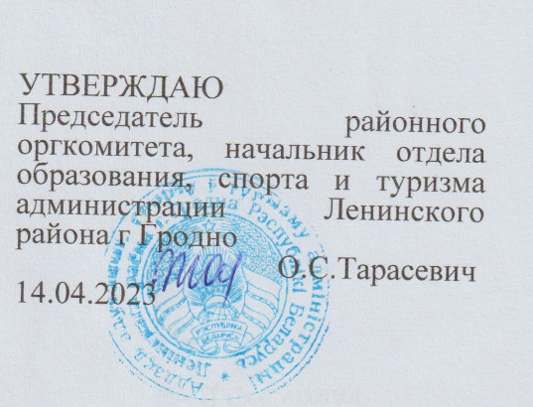

Situations for discussion 6th Form
- Nobody knows you better than you yourself. Speak about yourself.

- There are a lot of travel options. Why do people travel? Let’s talk about travelling.
3. Hobbies differ. Why do people need a hobby? Let’s talk about hobbies.

4. Does school mean only lessons for you? Let’s talk about school.

5. There are certain things in life which you have to do whether you like it or not. One of such things is household chores, doing which is a necessity. Let’s talk about your household chores.

6. People can’t live without food. Do you agree? Let’s talk about food.

7. Every country has its national dishes. What national dishes from your country would you recommend to the world? Let’s talk about Belarusian national cuisine.

8. What attracts tourists to Belarus? Let’s talk about Belarus.

9. Some people think that books make their life more interesting. Let’s talk about books and reading.
10. Each of us can do something to help nature. Let’s talk about ecology and ecological problems.

